Merging Duplicate Persons Guidelines/Protocol

- Each county has established a SACWIS Coordinator. The list of SACWIS Coordinators is being posted on the SACWIS Knowledge Base.
- A thorough search and analysis should be conducted prior to a merge being completed to ensure that the records are definitely duplicates. **Once Person Records are Merged, the Project is Unable to Unmerge them**
- If the duplicate person records were created and are “owned” by separate counties, the person who intends to merge the records should contact the SACWIS Coordinator for the other county so that each county is able to give input as to whether the records are in fact duplicates and which person should be retained and which should be removed. Note: The “owning” county is able to be determined by clicking on SACWIS History after a person search is completed. An agency is attached to the cases, intakes, and providers listed in the SACWIS history.
- The owning county when one record is associated with an open intake/case/provider and the other record is associated to closed intake/case/provider is the county who owns the open record. This is the county that should perform the merge.
- The owning county when both records are associated with a closed intake/case/provider is the county associated with the most recently opened record and this is the county who should perform the merge. Guideline number four should still be followed to determine which record should be retained and which should be removed.
- In general, it is recommended that the person record that contains more historical records/more information be the “retain” record.
- If the records obtain approximately the same amount of history/information, the retain record should be the record that has the more recent records attached to it.

Merge Person Step by Step
- 1) From your home screen click on the Administration tab.
- 2) Click on the Utilities tab
- 3) Select Merge Person on the left menu

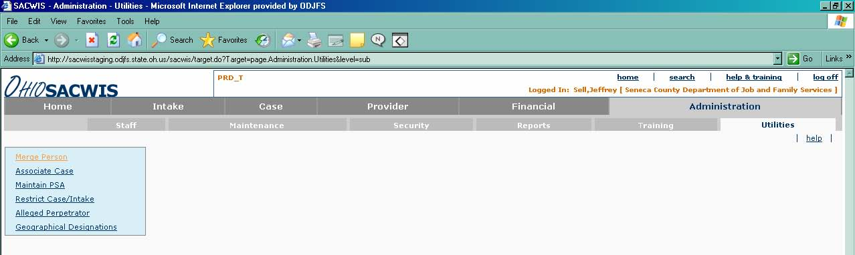

4) Click on the Search Person button (note: this is where you will search for you first person record that you wish to merge, this is the person that will be RETAINED)

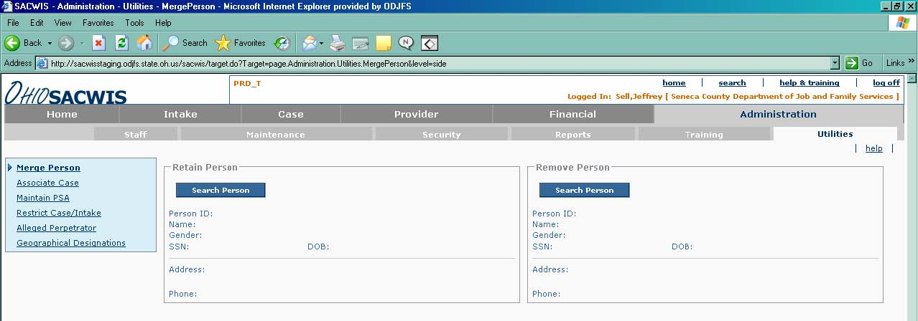

- 5) Fill in the person name or person ID of the person record that needs to be merged, click the Search button.

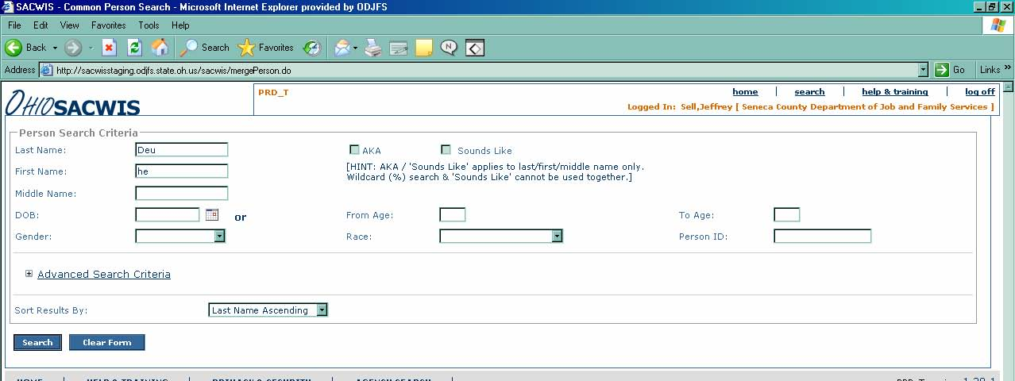

6) Pick the person record that you would like to merge by clicking the Select link to the left of the person ID.

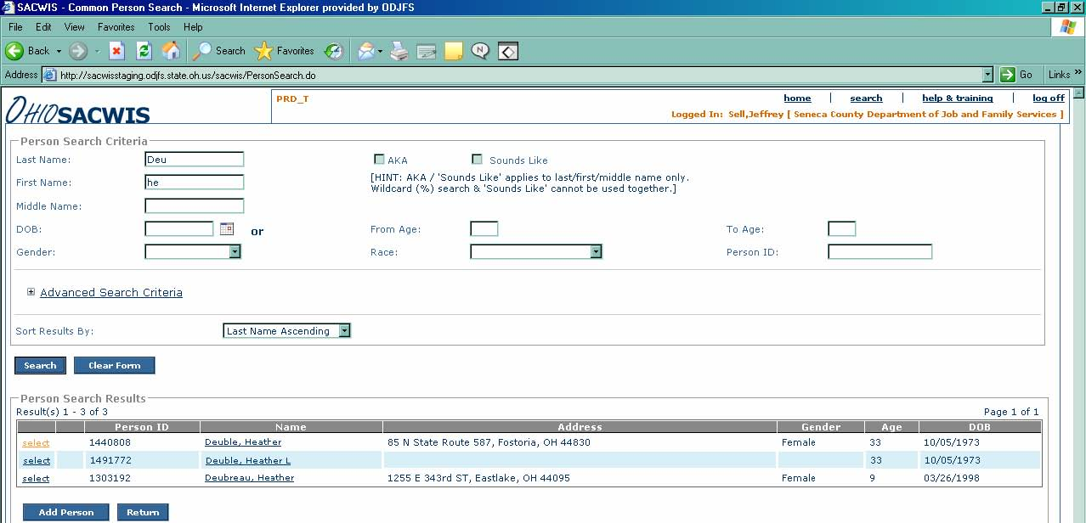

- 7) Repeat the previous steps for the second person record that you wish to merge, this is the person that will be REMOVED).
- 8) You now have both of your person records to merge, click Compare Records.

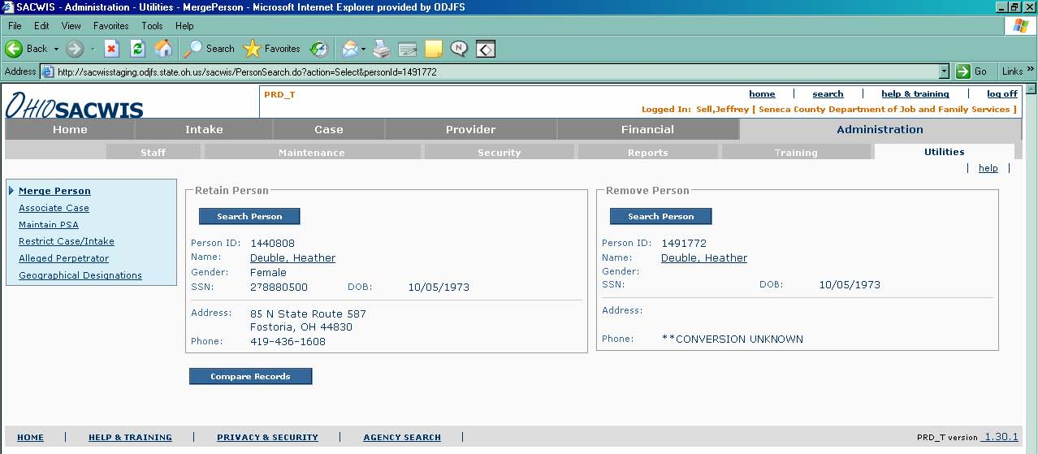



9) Here you can select each field that you would like to keep. Choose the appropriate information to keep by clicking in the Radio Buttons.
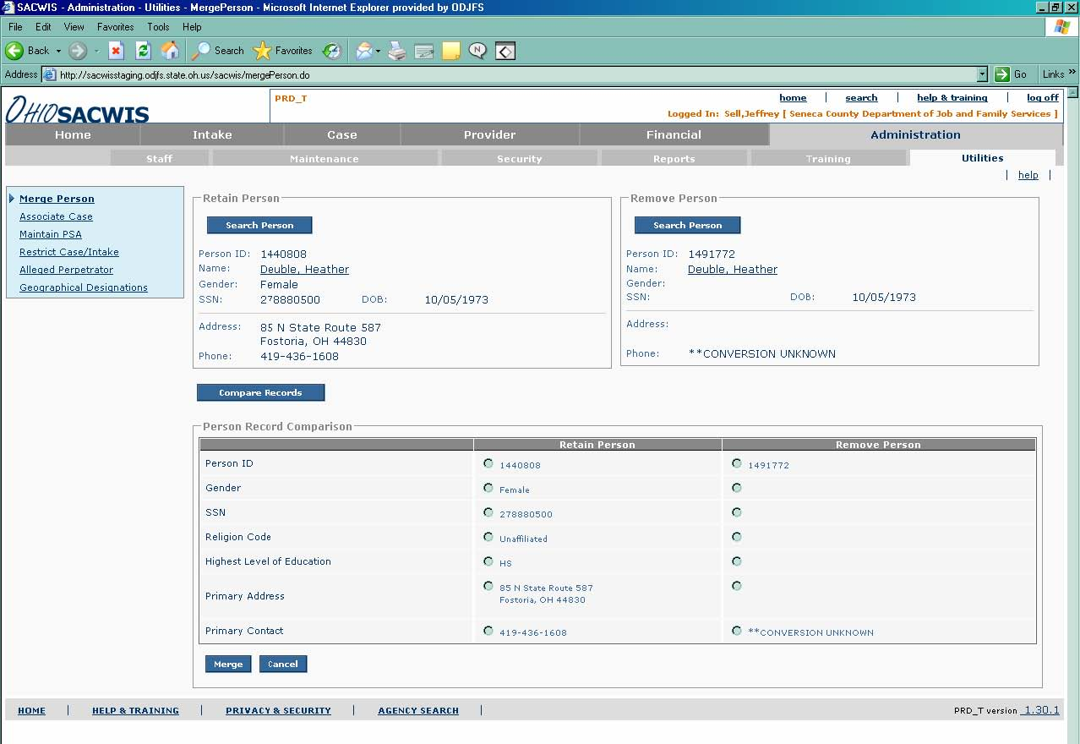
  - After selecting the desired information to be retained, click the Merge button.
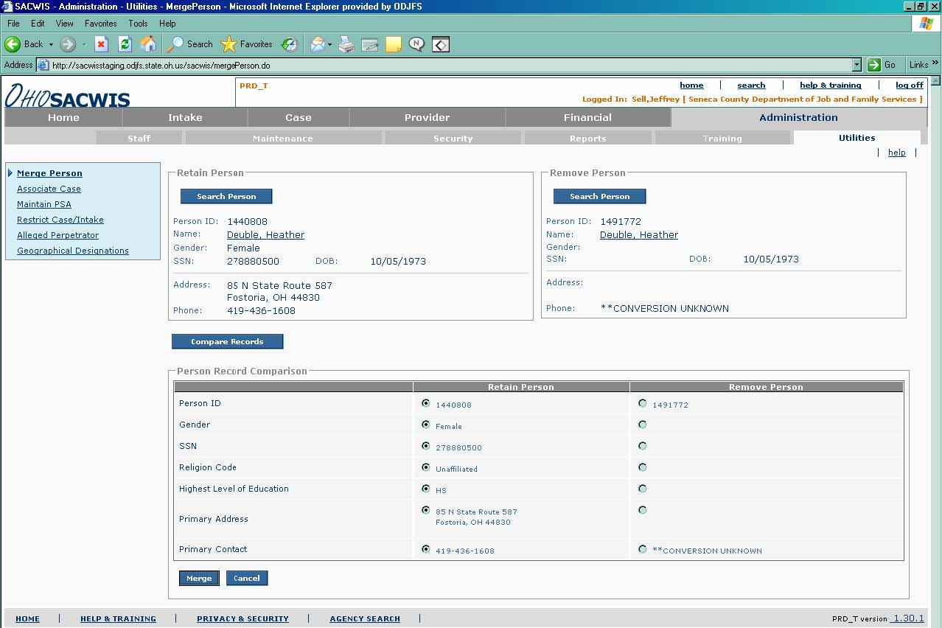
11) This window displays a successful merge. Click Close.
Person Merge Defects/Enhancements Recently Resolved
1) Change enhancement 7957 was resolved with build 1.74. This change
enhancement allows the of person records of where both persons involved
are case reference persons. These records can be merged as long as only
one of the cases is open. Additionally, the CRP of the open case must be the
“retain” person and the CRP of the closed case must be the “remove” person.
- It was previously recommended that the user add the “remove” person ID as a reference number on the retained person record. Enhancement 11342 was resolved with build 1.74. With this enhancement, the application will automatically add the person ID of the “removed” person record as a reference number under the additional tab on the person record.
- Defect 23270 was fixed with build 1.74. The participant link on provider activity logs is now being transferred to the “retained” person ID.
- Defect 23252 was fixed with build 1.74. The narrative of the description of family portion of the home study that was created with the “remove” person ID is still viewable when merging provider members.

Currently Logged Person Merge Defects/Enhancements
1) Defect 5411-Addresses the handling of Medicaid and IV-E numbers if those
numbers are not retained.
- Defect 24786-Prevents the merge of post-adoptive person records with person records that were created after the creation date of the post-adoptive record.
- Defect 25162-Allow the merge of intake participants if one of the participants is unknown.
- Defect 25214-Allow the merge of a members of a provider record if the “remove” person is in the provider history and there are no work items attached to that record.

Potential Problems When Merging Duplicate Person Records and Situations Where Person Records Cannot be Merged

- If the person record in question is pre-adoptive or post-adoptive person record, merges can only occur under certain circumstances. For the purposes of this article, a pre-adoptive person record is defined as a person record that is a past or present member of an Adoption Case. A post-adoptive person record is the new person record that was created upon an adoption finalizing in SACWIS. This person was made a member of the adoptive provider home at finalization (this occurred through the application automatically, not by the user). This record is linked to the Adoption Case. The linkage is visible to the user through the “View Original Person” tab in SACWIS History but this tab is only available to users with the appropriate security role.
- A pre-adoptive and post-adoptive person record cannot be merged. If this is attempted, an error message will be received.
- The “remove” person record in a person merge cannot have an adoptive history (as the pre-adoptive or post-adoptive person). If this is attempted, an error message will be received.
- A merge can be completed if the retain person record is the pre or post-adoptive person record and the remove person record does not.
- As stated above, the application will currently allow a person merge of a post-adoptive person record as the “retain” record when the “remove” record does not have an association with an adoption record. These records should only be merged if the “remove” record was created after the date of the adoption finalization (the date the post-adoptive person ID was created). It is recommended that the user view the SACWIS history of these records prior to merging them to ensure that the “remove” record was created after the creation of the post-adoptive person record. Enhancement 24786 has been logged requesting that the application prevent this from occurring.
- Person records that have overlapping financial records cannot be merged. Following are the specific financial work items that cannot have overlapping record in order for a merge to occur:
- Payment request records.
- Pending payment requests.
- Contract rate records.
- Conflicting benefit records.
- Eligibility records.
- State payment records.
- Agency reimbursement records.
- Adoption subsidy records.
- A merge cannot occur if either record has associated unapproved service
authorization records.
5) A merge cannot occur if there are pending payments on either person record
6) A merge cannot occur if the remove person is known to SETS.
7) A merge cannot occur if the retain and remove records have overlapping legal
status or placement dates.
8) If an error messages is received regarding overlapping addresses please
follow these instructions to resolve the issue:

Resolving Overlapping Addresses
- A. When you receive this error message, it means that an address and address type and effective dates overlap. You will need to go into both person records and make sure that none of the addresses have the same address type or time frames.
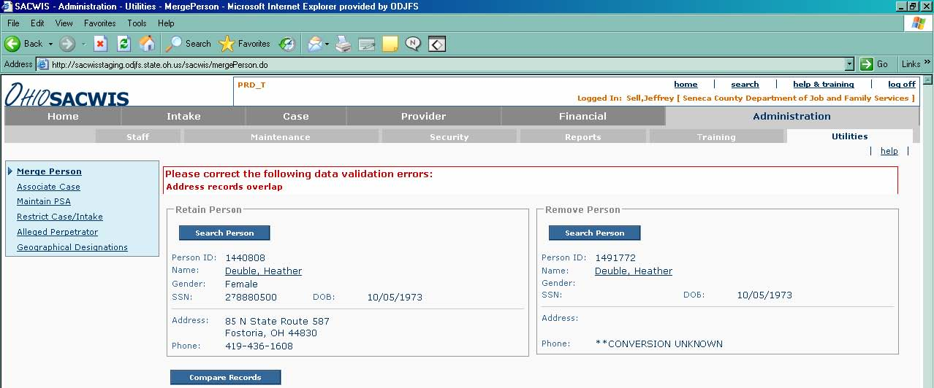

- B. Select the first person (Retain Person) record by clicking on the person’s name.

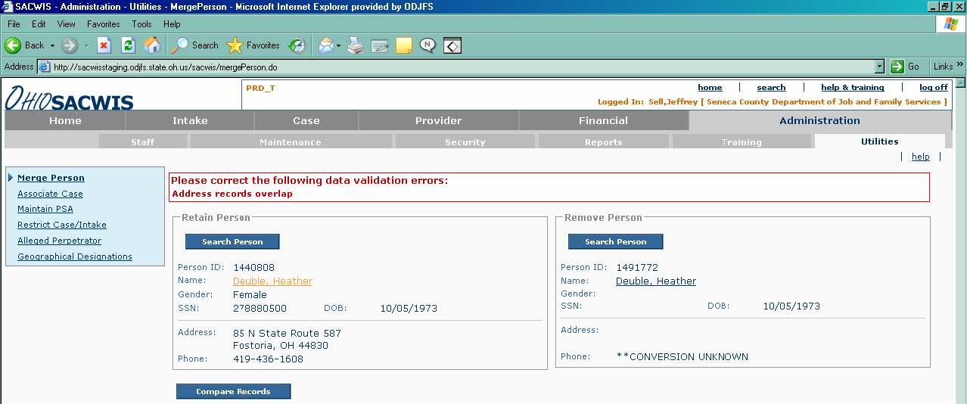

- C. On the Address tab, look at the address types and effective dates; no other address between both person records can have the same type (type examples are physical or mailing) and dates within the same time frame.
- D. Also review the second person’s (Remove Person) address history. Click Close button when finished looking at the dates
- E. When you have identified the dates, where either type, or dates overlap, you must decide which type or dates must be changed.
F. Select the person record that you wish to change the address on and click edit to the left of the address that needs to be changed.

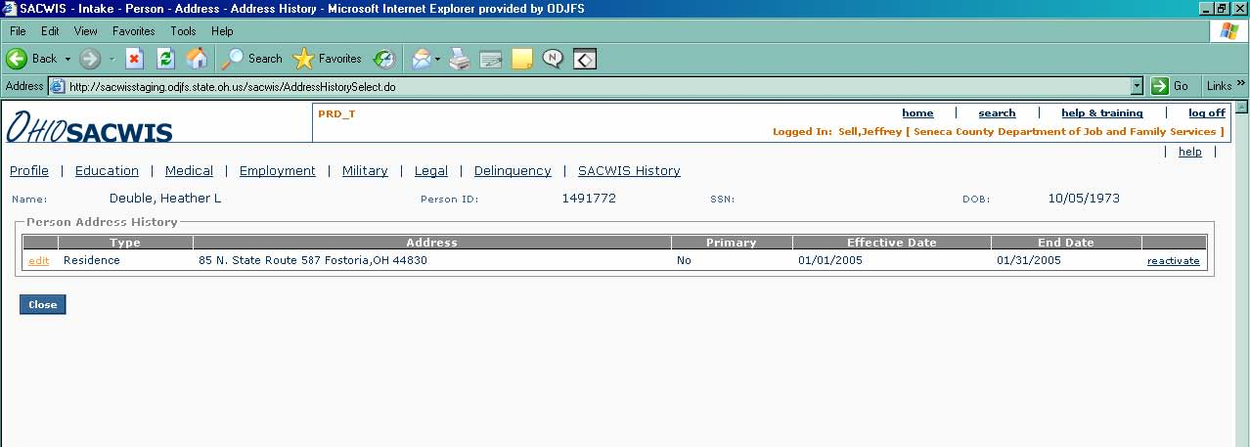

G. Change Type or Effective Date or End Date. Click Save.

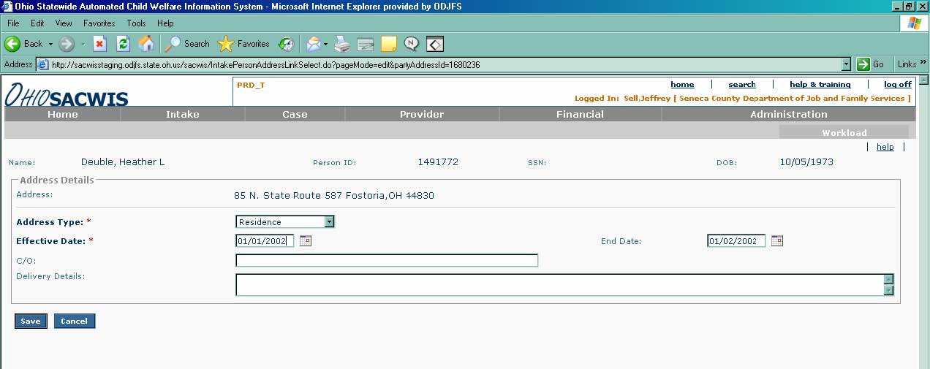

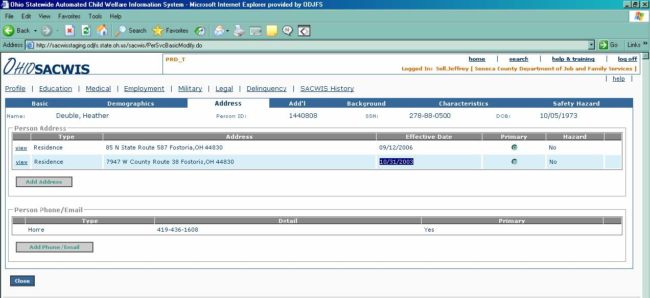

H. When returned to this screen click the Save button.

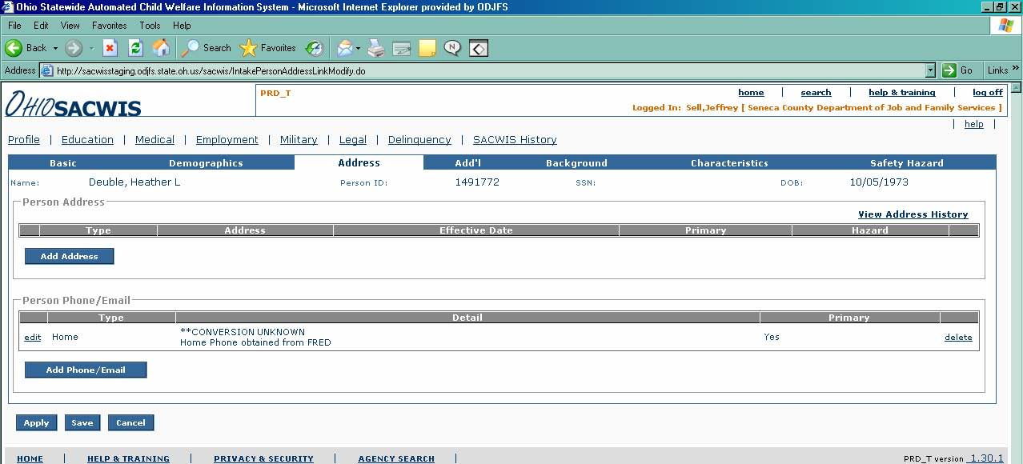

- I. You are now ready to merge the two person records. Click the Compare Records button. Please see the instructions at the beginning of the article.

